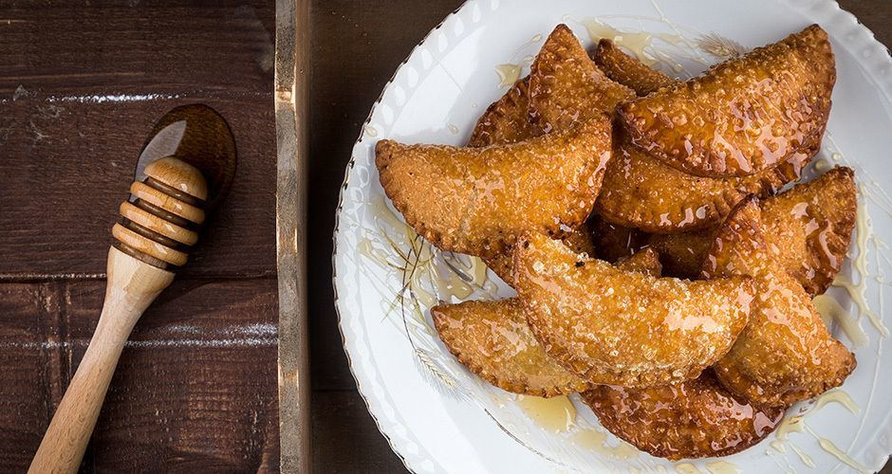
Greek cheese pies with mizithra and honey

Ingredients

For the dough
- 250 g water
- 90 g olive oil
- 20 g tsipouro
- 1 pinch salt
- 550 g all-purpose flour, + extra for rolling out the dough
For the filling
- 250 g mizithra cheese, fresh, crumbled with your fingers
- 1 teaspoon(s) cinnamon
- 2 tablespoon(s) granulated sugar
- 1 teaspoon(s) mint, dry
- 50 g milk
To assemble
- olive oil, for the frying
- honey, to serve

Method

For the dough
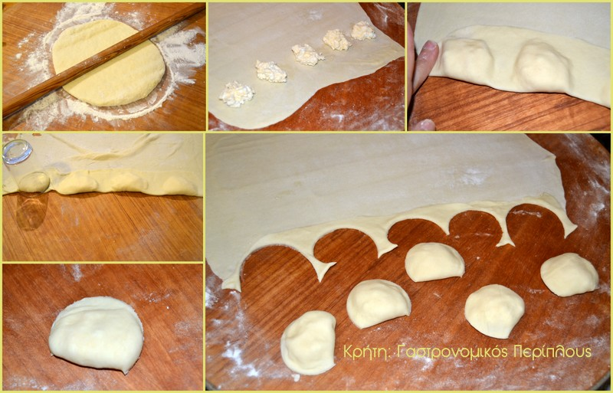
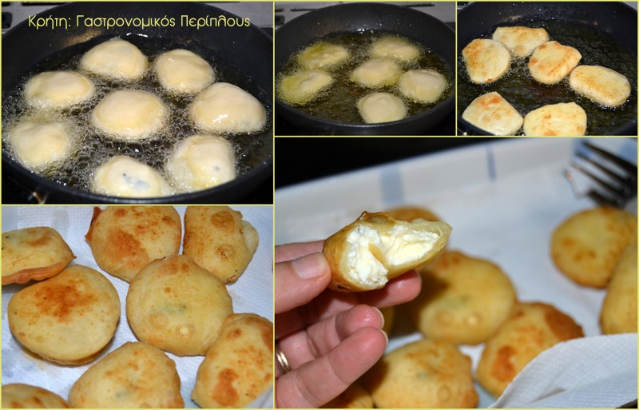

- Add all the ingredients in a large, plastic bowl except for the flour.
- Mix them well with a spoon and then, slowly add the flour. Firstly, mix with a spoon and then with your hands, until you get a soft dough that doesn’t stick.
- Add it to the bowl, cover it with a towel, and set it onto the counter or refrigerate for one hour to rest.
For the filling
- Mix all of the ingredients into a bowl, except for the milk. You want to get a malleable filling.
- In case the mizithra is a bit dry, add the milk little by little, until you get the desired consistency.
To assemble
- With a rolling pin, roll out the dough to a 1-2 mm sheet, by dusting with flour to prevent it from sticking.
- With a cookie cutter or a glass, cut round discs of 7-8 cm diameter.
- Divide the filling to the discs with a small spoon, and fold them in half to create half-moons.
- With a fork, press the join well so that the cheese pies will not open up while being fried.
- In case that the dough does not stick to the join, spread with a little water and press with the fork.
- Add the oil into a large frying pan, let it get very hot, and fry for 2 minutes on each side until they turn nicely golden.
- Drain them onto kitchen paper and serve them with honey.

