Ntakos

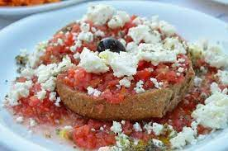

4 large round barley rusks
3 large mature tomatoes
8 tbsp olive oil
150 gr. Feta cheese
10-15 kalamata olives
1-2 tbsp capers
Oregano
Salt and freshly ground pepper
Moisten the rusks, with 2 tbsp of water each, and drizzle with the olive oil. Spread the mashed tomato on the rusks and add the crumbled feta cheese. Top with olive oil, capers and kalamata olives. Sprinkle with the oregano, salt, pepper and drizzle with some extra oil. Serve immediately.

