Stuffed Peppers and Tomatoes

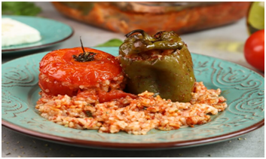

Ingredients

*6 large ripe tomatoes

*6 bell peppers

*2 tablespoons of olive oil

*1 small onion, finely chopped

*2 garlic cloves, crushed

*150g long grain rice

*salt and pepper

*a pinch of sugar

*parsley and basil (optional)
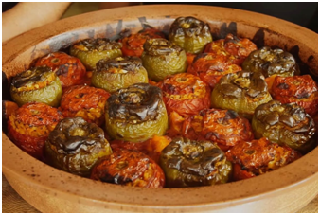

Instructions for the execution of the recipe

Cut a 2cm thick slice off the top of each tomato. Do the same with peppers. Scoop out their pulp with a teaspoon into a bowl and set aside. Heat the olive oil in a medium pan. Add the onion and garlic and cook over a medium heat, until soft but not browned. Add the tomato pulp to the pan, increase the heat slightly, and simmer vigorously for almost 10 minutes, stirring now and then, until the mixture is thickened. Make sure that there is some juice in the pan still. Stir in the rice, cover and leave to cook over a low heat for 10 minutes, until the rice is only half-cooked. Add salt and pepper and a pinch of sugar. Preheat the oven to 190°C fan. Put the hollowed out tomatoes and peppers into a slightly oiled baking dish and fill with the rice mixture. Replace the top. Bake in the oven for 35-40 minutes, until the tomatoes and peppers are tender and the rice is cooked through. Garnish with basil or parsley leaves and serve with feta cheese and bread.

